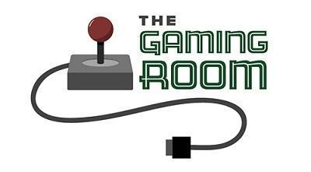

Draw It or Lose It

CS 230 Project Software Design Template
Version 1.0

Table of Contents

CS 230 Project Software Design Template 1
Table of Contents 2
Document Revision History 2
Executive Summary 3
Design Constraints 3
System Architecture View 3
Domain Model 3
Evaluation 3
Recommendations 5

Document Revision History

Version | Date | Author | Comments
1.0 | 03/18/26 | Kevin Peters | Initial release
1.01 | 4/4/2026 | Kevin Peters | Development requirements added
2.0 | 4/19/2026 | Kevin Peters | Final release

Instructions
Fill in all bracketed information on page one (the cover page), in the Document Revision History table, and below each header. Under each header, remove the bracketed prompt and write your own paragraph response covering the indicated information.

Executive Summary

Creative Technology Solutions (CTS) has been asked to redefine the existing game, "Draw It or Lose It." Originally developed for Android, the goal is to enable cross-play by transitioning to a web-based Java application while maintaining the original mechanics. To ensure system integrity, a Singleton Pattern has been implemented. This ensures that only one instance of the GameService exists in memory, preventing data conflicts and potential corruption.

Design Constraints

Transitioning from a local Android app to a web-enabled game changes how users interact with the system. We must now support multiple concurrent users accessing a centralized server. Because the client requires a single-instance coordinator for game logic, the server must be capable of tracking every game, team, and player instance globally, rather than relying on the user's device to manage local state.

System Architecture View

Please note: There is nothing required here for these projects, but this section serves as a reminder that describing the system and subsystem architecture present in the application, including physical components or tiers, may be required for other projects. A logical topology of the communication and storage aspects is also necessary to understand the overall architecture and should be provided.

Domain Model

The app is made of a main class that is used to start the making of the game. This includes the teams and players. This is done through the GameService class which uses a Singleton Pattern to make sure only one GameService class exists at a time. This is done with the GameService checking if there is already a running instance. It only creates a new instance if one is not found in memory. This creates a single point of control for the entire game environment.
The game creates a type of control using inheritance. The class Entity controls the attributes of id and name. Using Game, Team, and Player classes all deriving from Entity, the software is now set up to be reused as every object holds a consistent identity structure.
The client also requested unique names. This is accomplished by the GameService using the Iterator Pattern. Essentially, GameService does the same thing as with the Singleton Pattern, just instead of checking for its own existence, it checks for existing names in the list of games. If an identical name is found, it does not allow the new one to be created.

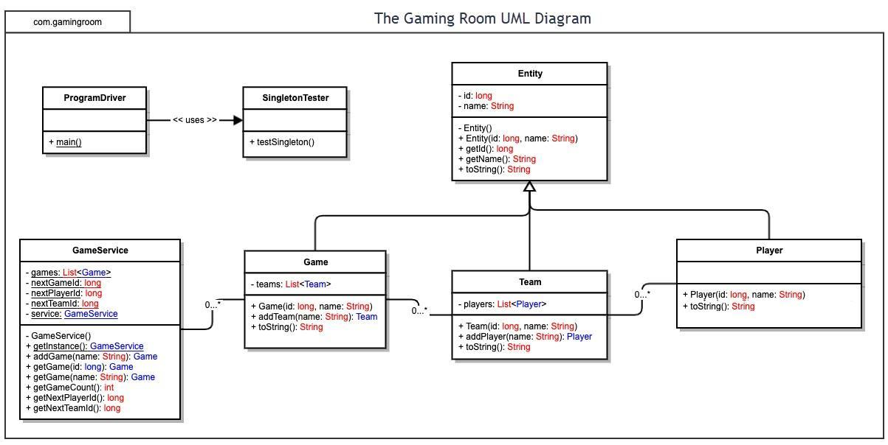

Evaluation

Using your experience to evaluate the characteristics, advantages, and weaknesses of each operating platform (Linux, Mac, and Windows) as well as mobile devices, consider the requirements outlined below and articulate your findings for each. As you complete the table, keep in mind your client’s requirements and look at the situation holistically, as it all has to work together.

In each cell, remove the bracketed prompt and write your own paragraph response covering the indicated information.

Development Requirements | Mac | Linux | Windows | Mobile Devices
Server Side | While MacOS is a UNIX-based operating system, the hardware behind it is not server grade. Mac stopped making servers in 2011 and buying a bunch of consumer grade PCs to host a server does not make sense financially for the hardware or the software. | This would be the most cost effective option for running a server. Not only are linux servers secure, but finding cloud hosts are super simple. The open source licensing is the best option here because secure server software can be free with $0 licensing fees for a java application | While Windows offers a 'Server Core' option for headless deployments to reduce overhead, it still carries significant licensing costs that increase with the number of users. Linux provides a similar headless environment with even lower resource consumption and zero licensing fees, making it the most cost-effective and scalable choice for a Java web application. | Mobile devices running servers should be left to home labs and not for major corporations. They are just not designed for the workload. Also the translation between ARM and x86 could lead to some unexpected results for servers.
Client Side | All four options are equally good. Some websites work best in a mobile or full-size browser, as long as those considerations are entered, a Mac would be a fine choice. It would be as simple as loading a web browser and connecting to the site. Cost would include the hardware and software of Mac-specific device. A fast and secure client experience can be had with all four client strategies. | Linux is the most flexible client-side option. It allows for the creation of free, legally redistributable bootable USB 'Kiosk' disks. This enables a dedicated environment where the GUI immediately loads the web application post-BIOS without user interaction, providing a seamless experience on almost any hardware with zero OS licensing costs. | Windows is the current go-to for desktop environments. Costs are on par with a mac pc but more expensive than a Linux pc or Android device due to OS licensing. As long as the software looks good on Chrome or Edge, the project should be fine on these devices. | The great thing about android is it is open source so it's free using things like AOSP (Android Open Source Project). The end user’s only cost is the hardware. With AppleOS, you are paying for the hardware and the operating system. Since mobile uses a different style of web browser, it is key to make sure the project looks good on both mobile and desktop browsers. Especially since mobile screens can be much smaller.
Development Tools | Cost and tools here are all subjective. A developer could use free software like eclipse or spend thousands on custom Mac-OS software. Again, the Operating system is an added cost above hardware. Programming languages are generally free. A single team can be used for all 4 development plans. | Cost and tools here are all subjective. A developer could use free software like eclipse or spend thousands on custom Linux-OS software. Here, the operating system is free so a developer could have 0 cost other than hardware. | Cost and tools here are all subjective. A developer could use free software like eclipse or spend thousands on custom Windows-OS software. Again, the Operating system is an added cost above hardware. Programming languages are generally free. | Depending on how this is setup, an OS such as ChromeOS or android (think of a raspberry pi connected to a desktop monitor) could work. A pi could be had for under $50. Paired with a keyboard and mouse, it could be used basically as a linux gui (because it is one).

Recommendations

Analyze the characteristics of and techniques specific to various systems architectures and make a recommendation to The Gaming Room. Specifically, address the following:

- Operating Platform: For the server-side architecture, I recommend a Linux distribution running Nginx, over Windows or other consumer-grade platforms. While Windows Server Core is a viable option, it introduces unnecessary licensing costs and significant resource overhead—requiring at least 1 GB of RAM and 5–10 GB of disk storage just for the operating system. In contrast, a headless Linux server running Nginx can operate efficiently on 256 MB of RAM and 1–2 GB of storage, allowing more hardware resources to be dedicated to game logic and image rendering.

Regarding the other platforms mentioned in the assignment, while macOS (OS X) and mobile platforms are capable of basic networking, they are not suitable for this specific use case. macOS lacks the modern server-grade hardware support necessary to sustain hundreds of simultaneous high-definition game instances. Similarly, mobile platforms are designed for client-side consumption rather than the heavy-duty throughput required for a multi-user server. While these platforms might support a small group of 15–30 users, a traditional server environment is required to ensure the scalability and stability requested by The Gaming Room.

- Operating Systems Architectures: Continuing with using Debian or another Linux server grade flavor, we need to discuss how Linux works versus Windows Server. Windows Server was designed with a GUI in mind. It takes a lot of resources for that server to work. On the plus side, it allows ease for setting up additional services like printer services, and file servers. But with all this ease, there is a lot of bloat. Even with Server core, Windows removed the GUI but a lot of the extra stuff is still there because it was built with a GUI at its core. The beautiful thing about Linux is it is all modular. You can simply install the base operating system, install the web server, and that is all that will run. This shrinks a high remote attack field with a much smaller one as there are simply fewer services to attack. With Linux there is no need for things like a GUI, PowerShell or .Net Framework. You simply add the packages you need along with dependencies, and start pushing services.

- Storage Management: If The Gaming Room is hosting the servers internally, the use of a RAM disk or SSDs (Solid State Drives) is highly recommended to ensure rapid data retrieval. While a traditional mechanical hard drive could technically host files for a small group of 10–20 users, performance will degrade rapidly as the user base scales due to physical seek-time limitations. As multiple users simultaneously request different 8 MB high-definition assets, a mechanical drive would experience a significant I/O bottleneck, resulting in latency that disrupts the 30-second rendering cycle.

However, an even more effective approach is to utilize a RAM-cached storage strategy. Since the entire 200-image library is only 1.6 GB, which is a trivial amount of space by today's server standards, the system can load the entire library into RAM upon startup. This would allow even a server equipped with traditional mechanical hard drives to perform at elite levels; once the initial load is complete, users would pull images at the speed of the system’s memory bus. RAM speeds are significantly higher than even the fastest NVMe SSDs, ensuring that the server can handle hundreds or even thousands of concurrent requests with near-zero latency.

For storage on the client side, it really doesn’t matter if users are using SSDs or standard spinning hard drives. The game will not start until the images are loaded into RAM, and a standard spinning disk is more than capable of handling an 8 MB file or two.

- Memory Management: The operating system uses Virtual Memory to keep the game stable. By giving the game its own isolated space in the RAM, the OS makes sure that if the game encounters a bug, it doesn't take down the entire server. On the client side (like a player's phone or laptop), we use Demand Paging. This means the device only loads the specific images needed for the round they are playing right now. This stops the game from hogging all the phone's memory, so the player can still get notifications or check other apps without the game crashing.

- Distributed Systems and Networks: With modern web applications, most users are going to be able to connect to a public server as long as the internet connection is not setup as a Zero-Trust network. In cases of Zero-Trust, the user would need to get with the network admin and explain why they needed access to the application. All other clients that have internet should be able to easily connect to a public server. This includes things like the Xbox, which while it does have its own Microsoft network, will still allow you to connect to generic web pages without additional configuration. For this type of application, the server becomes the “source of truth.” The server is what keeps track of what’s going on. If a client disconnects, the server realizes it, and communicates that information to the other clients. With cellular connections, we need to make sure that both the client and server can deal with temporary and/or complete disconnects and not freak out when it happens.

- Security: To keep user info safe, we use a "defense-in-depth" approach. First, we use TLS 1.3 encryption, which acts like a secure tunnel for data traveling between the player and the server. This prevents malicious actors from "sniffing" the network traffic to steal passwords or game data.

On the server, we follow the principle of Least Privilege. This means the game software is restricted so it only has permission to touch its own specific folder and nothing else. We also make sure that only a true administrator has full system access, while everyone else—including the game service itself—operates with restricted guest-level access. This prevents unauthorized people from writing malicious files or compromising the server's integrity.

For the client side, the game should run in a Sandbox. This is a built-in security layer that prevents the game from ever seeing the player's private photos, personal files, or other sensitive data on their device. While this might not seem crucial for a simple drawing game, it adds an important layer of protection for the user in case the server is ever hacked or a "man-in-the-middle" attack occurs.

